Core Value- Respect 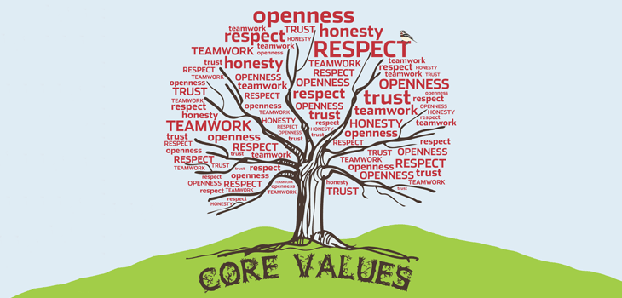
“Kind words can be short and easy to speak, but their echoes are truly endless.” - Mother Teresa
During the month of March we will be focussing on understanding and developing the core value of ‘respect’. In our lives our children need to show respect for others. This may be at home, school, in the community, work place and indeed our church. At Duneane Primary School we want to nurture the relationship between staff, pupil and parent for the wellbeing of everyone. We value very much your support at home, and invite you to discuss some of the following issues or points with your child:
- Showing respect to those who look after us
- Practical ways of showing respect in school and how to improve the respect you show to others
- Respect for others such as – taking your turn in class, respecting others’ opinions
- How can we show respect in our school or home
Showing respect? – Some helpful tips
- Show respect for others in the school community regardless of who they are
- Respect for all the people who work in our school to include teachers, assistants,
supervisory staff, the caretaker and secretary
- Respect for the church as a place of worship to God
- Respect for other people’s property, belongings and toys
- Reflect on the love of God and how He has given us others who care and give us
- caring examples
- Missionary work - working for a better world and giving of ourselves to help others
- Help children to become involved in-kind deeds for others
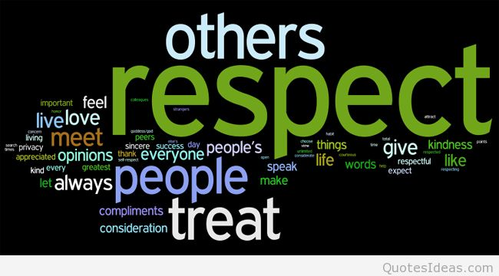
- Children can focus on how our school adults care and help them
How can we show gratitude through our actions
- We will discuss respect through Assembly & Circle Time
- Think about manners and the appropriate language and behaviour associated with respect
- Respect for our parents, brothers and sisters
- Respect for people in our community and our neighbours
- Respect for the elderly
- The best way to earn respect is to give respect
- Respect for ourselves guides our morals; respect for others guides our manners
Treat others as you want them to treat you!

